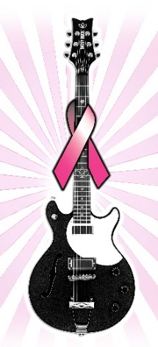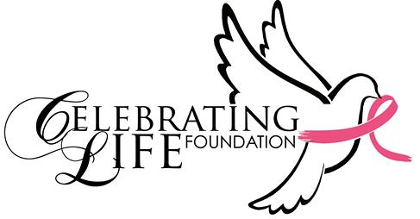

August 7, 2017

Dear Vendor:
On behalf of The Celebrating Life Foundation, I would like to thank you for being a vendor at the 16t^{th} Sister to Sister Fitness Festival.
Since its inception in1995, The Celebrating Life Foundation has distributed over a million breast self exam cards, hosted concerts and luncheons supporting breast cancer awareness and conducted 14 other Sister to Sister Fitness Festivals. Our efforts have been listed in Essence Magazine, JET Magazine and numerous newspapers across the country.
The 16th Sister to Sister Fitness Festival will be held on Saturday, October 7st at the Cedar Hill Recreation Center. The Alan E. Sims Cedar Hill Recreation Center is located at 310 East Parkerville Road, Cedar Hill, Texas 75104.
We are asking all vendors to set up between 7:00 AM and 8:00 AM on this Saturday. You can also set up after 5:00 PM on Friday night. Our aerobic workout will start promptly at 8:00 AM.
Stephania Schirru will be your contact on the day of the event. She will tell you where your table is to be set up at, and assist you with any other questions on that day. We look forward to your participation this year.
We will provide tables, chairs and electricity if needed, please provide your own table cloth. If you have not already done so, we are asking that you provide one item that can be given away as a door prize at the event. Thanks in advance for your continued support!
Please make a $50.00 donation on our website to cover your vendor fee.
If you have any questions, please call 214-475-0661.
Sincerely,
Sylvia Dunnavant
Celebrating Life Foundation/ Founder

